**KABOJJA JUNIOR SCHOOL**

**P.2 LUGANDA MID – TERM EXAMS I, 2024**

**Time Allowed: 2hrs 30 minutes**

**NAME**: ……………………………………………………………………………………………………………………….

**DISTRICT:** …………………………………………………… **CLASS:** ……………………………………….

1. **Wandiika ennukuta enjogeza taano**.

_____________ _____________ ______________

_____________ _____________

2. **Wandiika ennukuta taano ensirifu**.

____________ ____________ _____________

____________ ____________

3. **Jjuuzaamu ennyingo ezibulamu**.

ma ____ mi ____ mu

____ we ____ wo ____

____ de ____ ____ ____

nsa ____ nsi nso ____

bwa bwe ____ ____ ____

4. **Ssaza ennukuta kubigambo**.

1 _______________ssatu

2 _______________taano

3 _______________emu

4 _______________ bbiri

5 _______________nnya

5**. Gatta ennyingo zino okole ebigambo**.

o_mu_so_me_sa _______________________________

o_mu_sa_wo ________________________________

o_mu_ba_zi ________________________________

o_mu_yi_zi ________________________________

o_mwa_na ________________________________

6. **Soma okube ebifanaanyi.**

|  |  |  |  |  |
| --- | --- | --- | --- | --- |
|  |  |  |  |  |
| ekitabo | ennoni | emmeeza | entebe | ekkalaamu |

7. Ssaza abantu betusanga mu kitundu kyaffe nebyebakozesa.

omusomesa machini

omubazi ennoni

omusawo empiso

makanika enyondo

8. Ssaza akakubo.

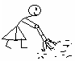 Ono akolaki?

atudde

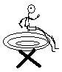

asoma



ayera

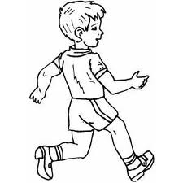

abuuka

9. Jjuzaamu ennukuta ezibulamu.

ak___mbe ensaw___ enno___ni ek___tabo.

10. Soma okube ebifanaanyi.

omusomesa ________________________

omubazzi __________________________

omusawo __________________________

makanika __________________________

kinnyozi _________________________